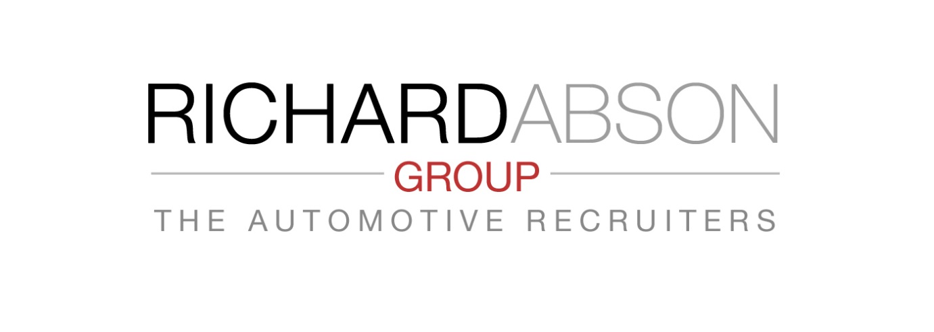Key Elements of a Thorough Recruiting Process

Part 4 - Source of Candidates.
We have maintained an impartial view on providing advice to your business on a most Effective Recruitment Process – irrespective of where you draw your candidates from. It is important that we maintain that stance in principle. This next Element focuses on where you get your candidates from. There are many and varied sources of candidates, and we would like to draw your attention to them, along with the pros & cons. The Ultimate objective throughout your process should be :
To attract and secure the very best person available, who will make the biggest impact on your business – however you may define that!
Sources of Candidates
- Advertising – local press, trade journals, job centre, job boards
- Networking
- Someone you know
- Internal promotion
- Agencies - General agencies
Motor specific - but possible CV farmers Bespoke Motor agencies (search & selection to your specification)
The most important function is to acquire the BEST person. You therefore do need to attract a minimum of 3 candidates who you perceive will meet your specified needs.
Advertising rarely works these days – Good people are happy doing a good job, and don’t search through advertisements. Choosing from here is likely to end with best of a poor bunch.
Networking & Someone you know – can work, but if one candidate is pursued, how do you know there’s not a better one? It is always better to have others for comparison!
Internal Promotion – by definition of that person’s status, he/she is not fully skilled in your needs, and therefore will need time to mature and be trained – does the appointment allow that time, or do you need that stronger person NOW. Saving costs from internal promotion may be at the loss of business performance in not having the Right person in place. Internal promotions are good for the right reason.
Agencies - These usually fall into 2 brackets:
• Cheap and cheerful CV Farmers – Those who do not take a detailed specification from you, and therefore cannot know what your EXACT needs are. They often do not meet their candidates. CVs are sent out on a ‘hit or miss’ basis – and occasionally they win – BUT is this ‘best of a poor bunch again’, for cost savings?
• Bespoke Search & Selection – Choose an agency who works for YOU - knows you and your business, obtains a full specification from you, searches the market for best fit candidates, meets and assesses them, and sends you 3 or 4 ‘qualified’ CVs for you to make a ‘‘Best Selection’ from.
It’s not the cost of recruitment that is important BUT employing the Right person for true Productivity benefits.

The Automotive Recruiters - Tel : 01829 730116 or
info@the-AMR.com

